Question 1: Classify each product by price into the three tiers below
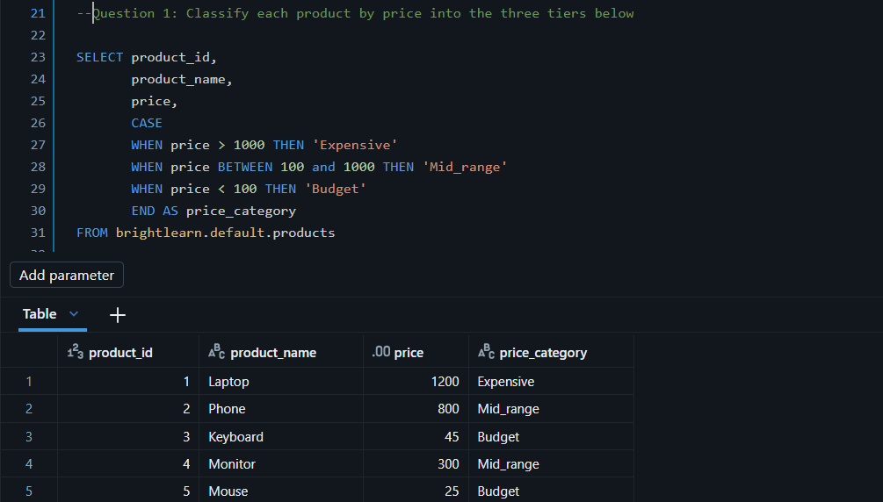

Question 2:Label each order by its value.
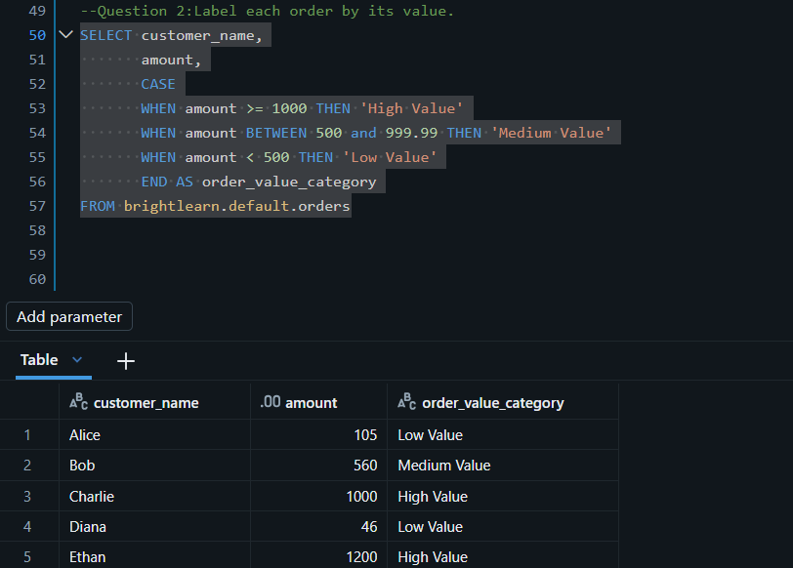

Question 3: Categorize each employee's position level using both department and salary
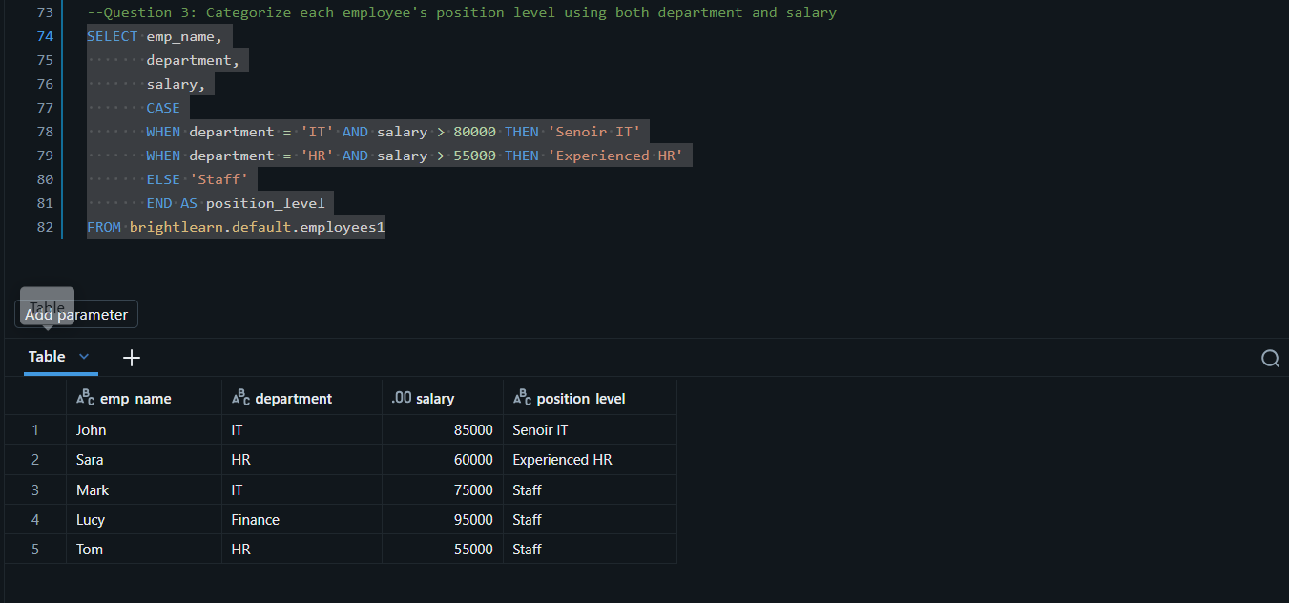

Question 4: Assign each student a letter grade based on their score
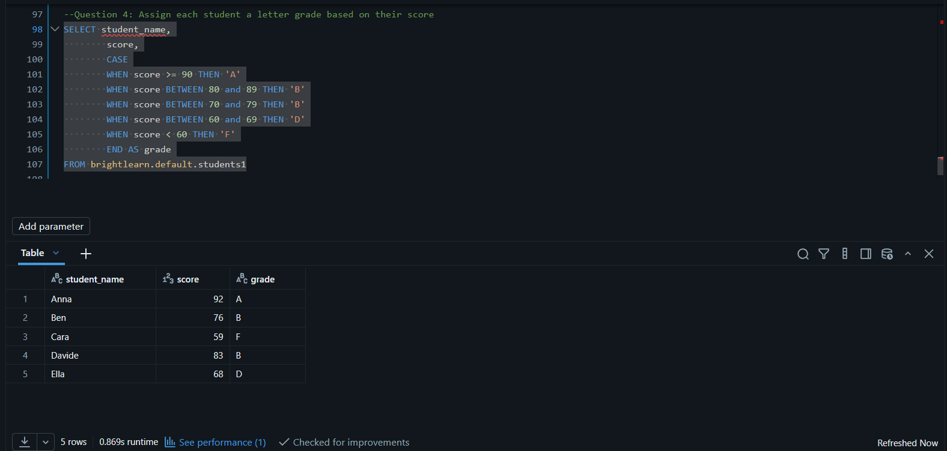

Question 5: Label delivery performance based on the time taken.

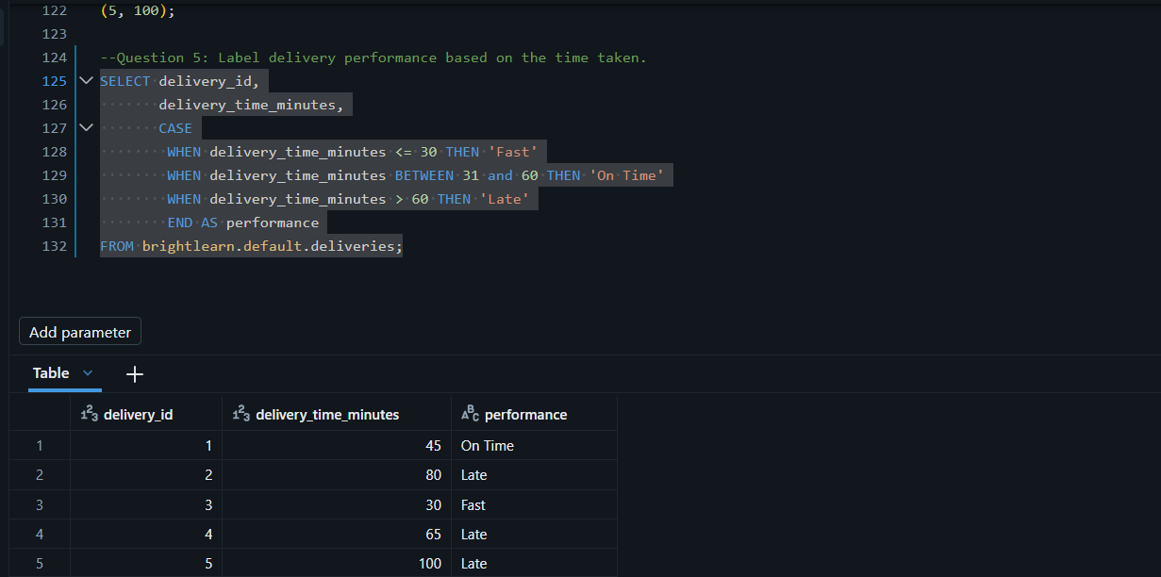

Question 6: 06 Convert the numeric priority into a readable label.
